**Calculating Family Expenses Using Service Now**

**Team Id:NM2025TMID18598**

**Team Members:**

Team Leader: K.JAISREE

Team Member1: R.RAJESHWARI

Team Member2: R.BAVADHARANI

Team Member3: R.JANANI

**TASK INITIATION**

**Calculating Family Expenses Using Service Now**

Milestone 1: Setting Up Service Now Instance

Activity1: Sign up

1 .Sign Servicenow.com in the personal developer instance

2. <https://developer.servicenow.com>

### 3. Once logged in , navigate to the "Personal Developer Instance" section.

4. Click on "Request Instance" to create a new Service Now instance.

5. Fill out the required information and submit the request.

6. You'll receive an email with the instance details once it's ready.

7. Log in to your Service Now instance using the provided credentials.

8. Now you will navigate to the Service Now.

Milestone 2: Creation Of New Update Set

Activity1: Creation Of New Update Set

1: Go to All >> In the filter search for Local Update set > click on New.

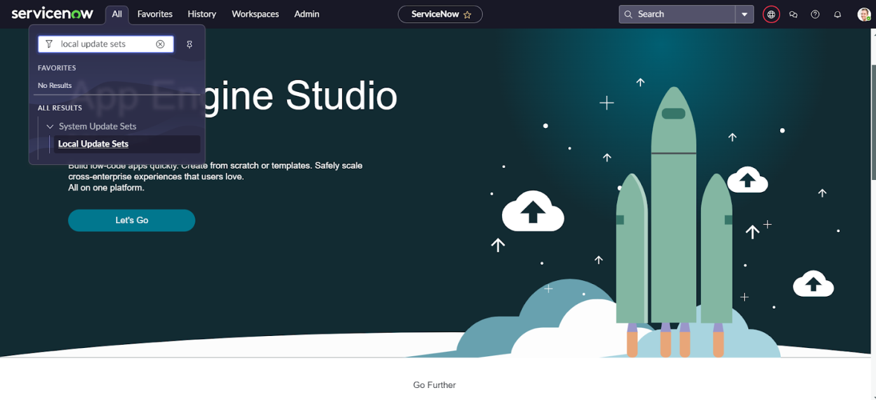

1. Enter the Details as:

Name: Family Expenses

1. Then click on Submit and Make current.

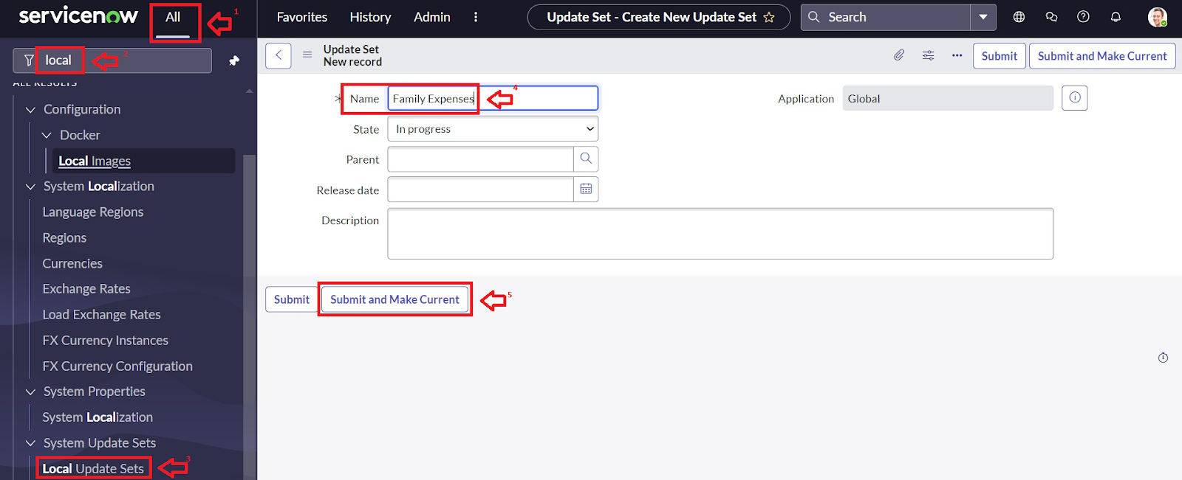

Milestone 3: Creation Of Table

Activity 1: Creation Of New Update Set

1. Go to All >> In the filter search for Local Update set > click on New.



1. Enter the Details as:

Name: Family Expenses

1. Then click on Submit and Make current



Milestone 4: Creation Of Table

### Activity 1: Creation of Family Expenses Table

1. Go to All > In the filter search for Tables > click on New.
2. Enter the Details:

Label : Family Expenses

Name : Auto-Populated

New menu name : Family Expenditure

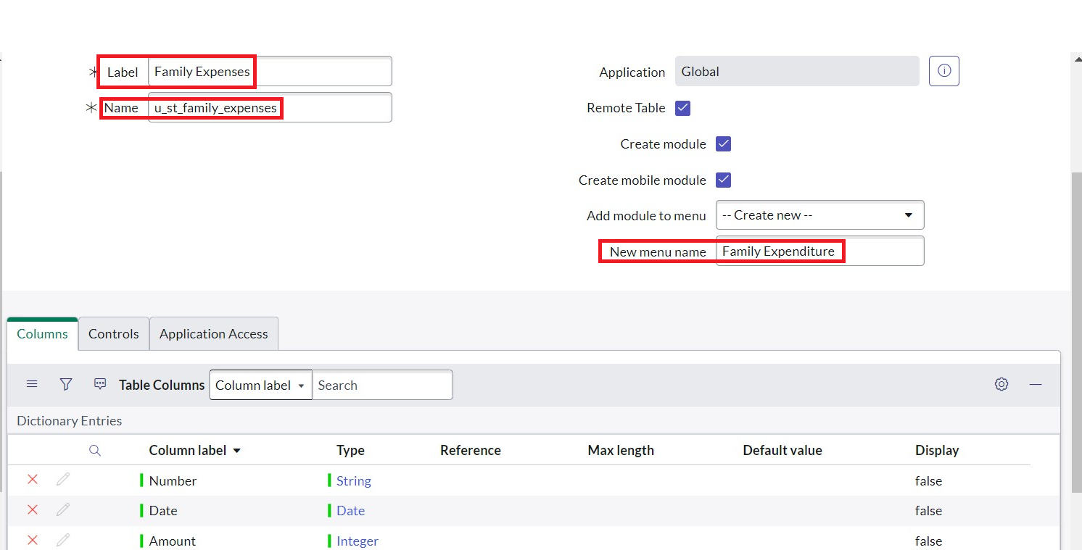

1. Go to the Header and right click there>> click on Save.

### Activity 2: Creation of Columns(Fields)

1. Near Columns Double click near insert a new row.
2. Give the details as:

Column label : Number

Type : String

1. Double click on insert a new row again
2. Give the details as:

Column label : Date

Type : Date

1. Double click on insert a new row again
2. Give the details as:

Column label : Amount

Type : Integer

1. Double click on insert a new row again
2. Give the details as:

Column label : Expense Details

Type : String

Max length : 800

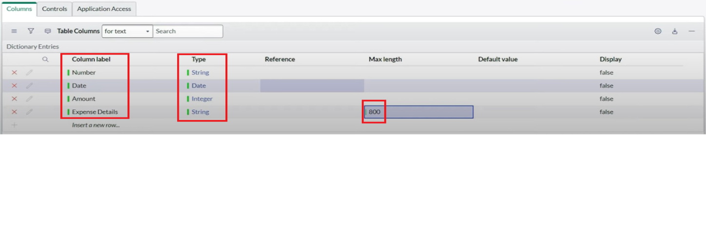

1. Go to the Header and right click there>> click on Save

### Activity 3: Making Number Field an Auto-Number

1. Double click on the Number Field/Column.
2. Go down and double click on Advanced view
3. In Default Value:

Use dynamic default : check the box

Dynamic default value : Get Next Padded Number

1. Click on Update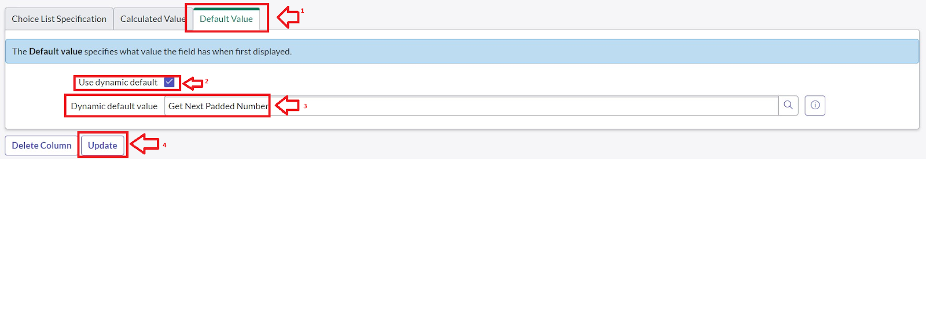

5. Go to All >> In the filter search for Number Maintenance >> select Number Maintenance

6. Click on New.

7.Enter the below Details:

Table : Family Expenses

Prefix : MFE

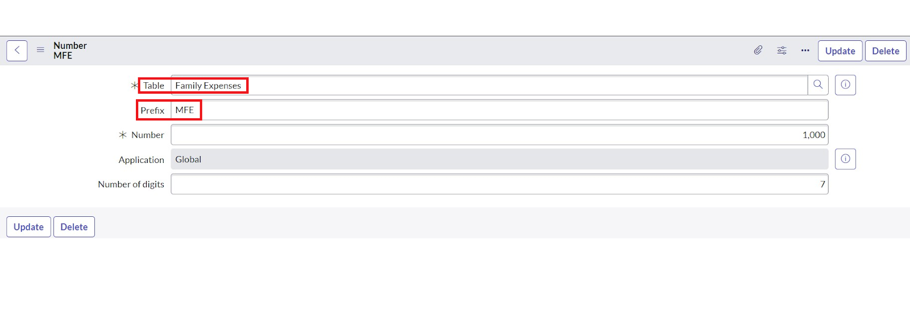

8. Click on Submit.

### Activity 4:Configure the Form

1. Go to All >> In the filter search for Family Expenses >> Open Family Expenses
2. Click on New
3. Go to the Header and right click there>> click on Configure >> Select Form Design
4. Customize or Drag Drop the form as per your requirement.

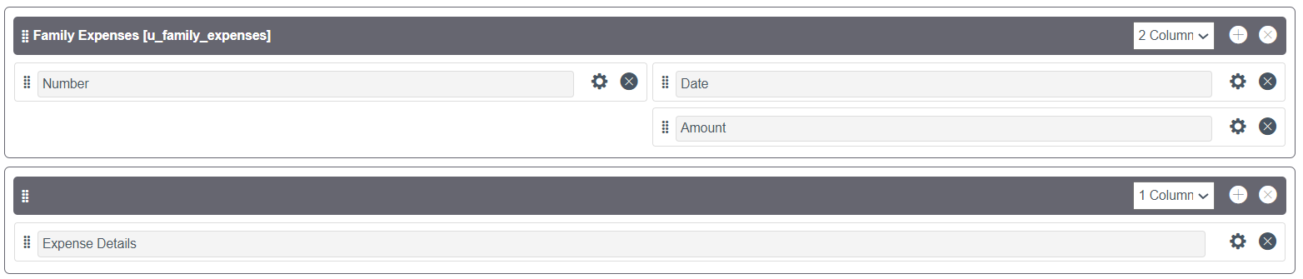

1. Make Number Read-Only Field by clicking on the gear icon and checking Read-Only
2. Make Date, Amount Mandatory Field by clicking on the gear icon and checking Mandatory
3. Click on Save.

Milestone 5: Creation Of Tables (Daily Expenses)

### Activity 1: Creation of Daily Expenses Table

1. Go to All > In the filter search for Tables > click on New.
2. Enter the Details:

Label : Daily Expenses

Name : Auto-Populated

Add Module to menu : Family Expenditure

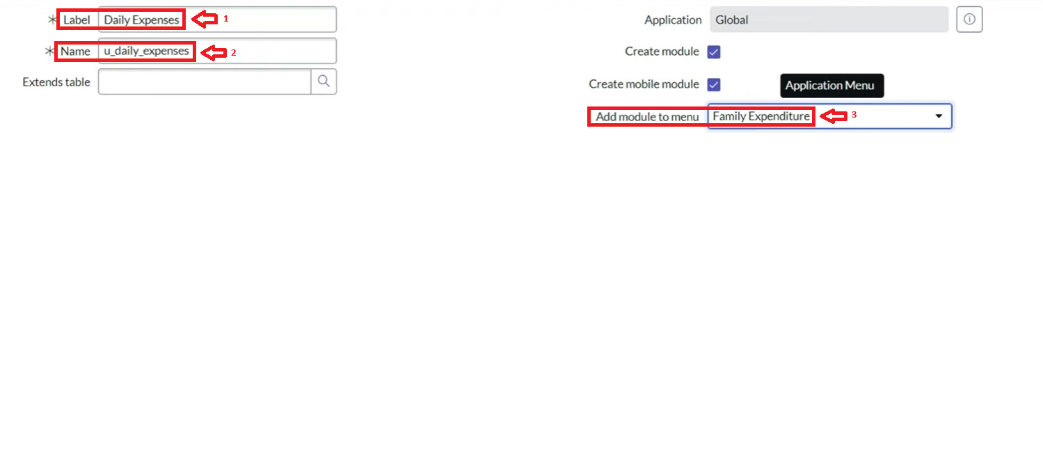

1. Go to the Header and right click there>> click on Save.

Activity 2: Creation of Columns(Fields)

1. Near Columns Double click near insert a new row.
2. Give the details as:

Column label : Number

Type : String

1. Double click on insert a new row again
2. Give the details as:

Column label : Date

Type : Date

1. Double click on insert a new row again
2. Give the details as:

Column label : Expense

Type : Integer

1. Double click on insert a new row again
2. Give the details as:

Column label : Family Member Name

Type : Reference

Max length : 800

1. Double click on insert a new row again
2. Give the details as:

Column label : Comments

Type : String

Max length : 800

1. Go to the Header and right click there>> click on Save.

### Activity 3: Making Number Field an Auto-Number

1. Double click on the Number Field/Column.
2. Go down and double click on Advanced view
3. In Default Value:

Use dynamic default : check the box

Dynamic default value : Get Next Padded Number

1. Click on Update.

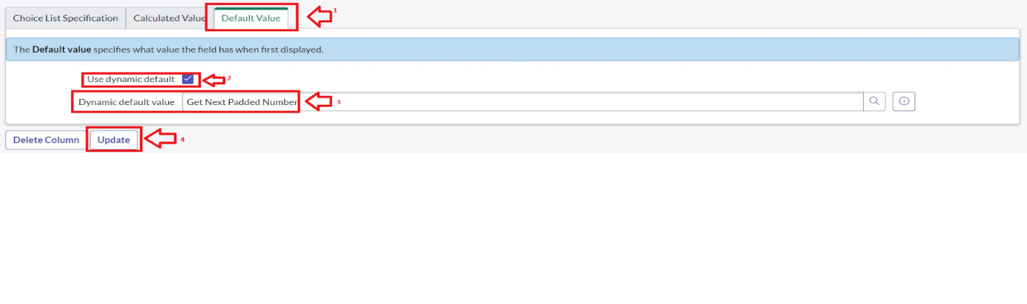

1. Go to All >> In the filter search for Number Maintenance >> select Number Maintenance
2. Click on New.
3. Enter the below Details:

Table : Family Expenses

Prefix : MFE

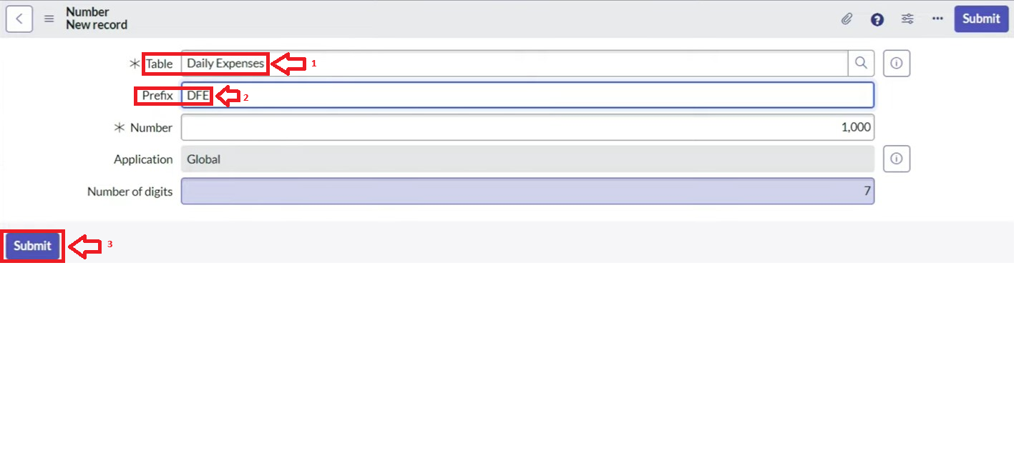

8. Click on submit

### Activity 4: Configure the Form

1. Go to All >> In the filter search for Daily Expenses >> Open Daily Expenses
2. Click on New
3. Go to the Header and right click there>> click on Configure >> Select Form Design
4. Customize or Drag Drop the form as per your requirement.

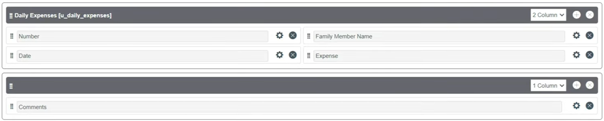

1. Make Number Read-Only Field by clicking on the gear icon and checking Read-Only
2. Make Date, Family Member Name Mandatory Field by clicking on the gear icon and checking Mandatory
3. Click on Save.

Milestone 6: Creation Of Relationship

### Activity 1: Creation of Relationship between Family Expenses and Daily Expenses tables

1. Go to All >> In the filter search for Relationships >> Open Relationships
2. Click on New.
3. Enter the details:

Name : Daily Expenses

Applies to table : Select Family Expenses

Daily Expenses : Select Daily Expenses

1. Click Save.

### Milestone 7: Configuring Related List on Family Expenses

### Activity 1: Configuring Related List on Family Expenses

1. Go to All >> In the filter search for Family Expenses >> Open Family Expenses
2. Click on New
3. Go to the Header and right click there>> click on Configure >> Select Related Lists
4. Add Daily Expenses to the Selected Area.

5. Click on Save

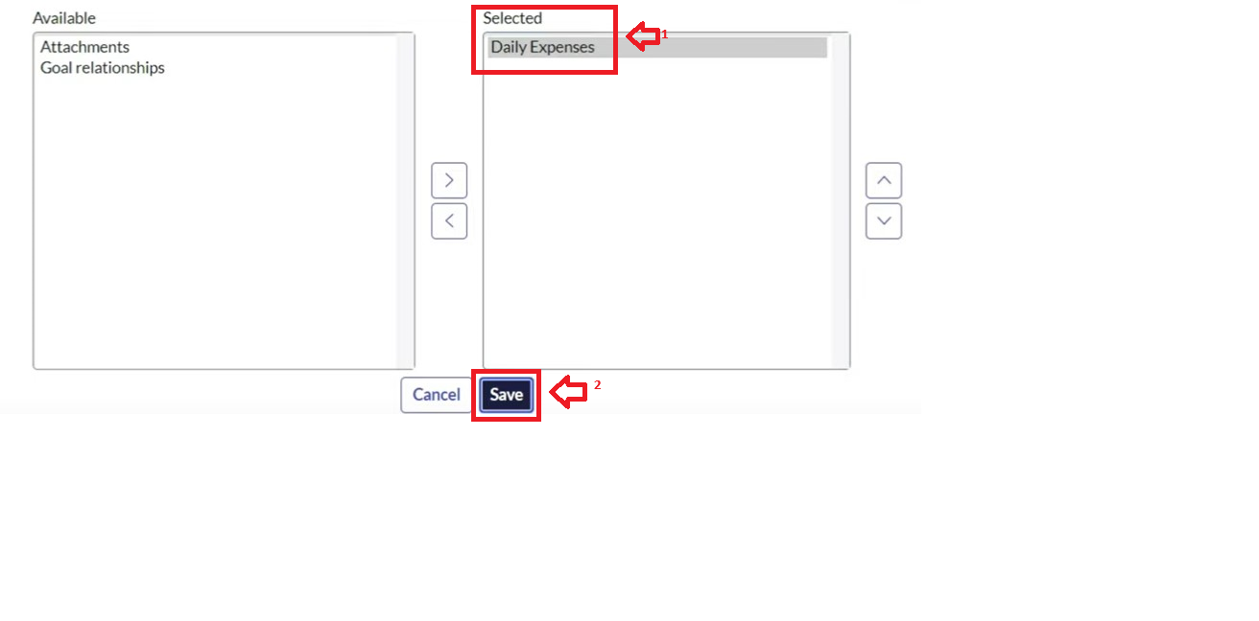

Milestone 8: Creation of Business Rules

Activity 1: Creation of Business Rules

1. Go to All >> In the filter search for Business Rules.
2. Under System Definition Select Business Rules then click on New.
3. Enter the Details:

Name : Family Expenses BR

Table : Select Daily Expenses

Check Advanced

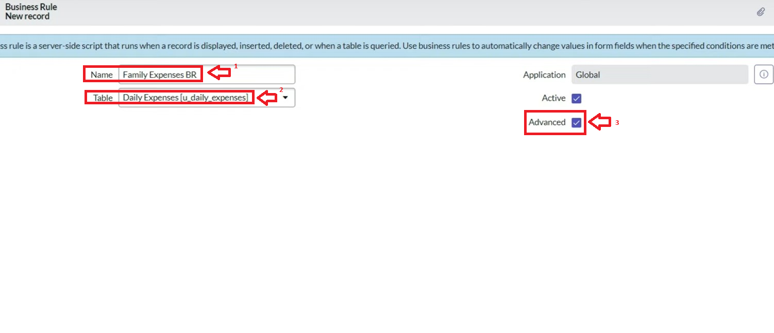

1. In when to run Check Insert and Update

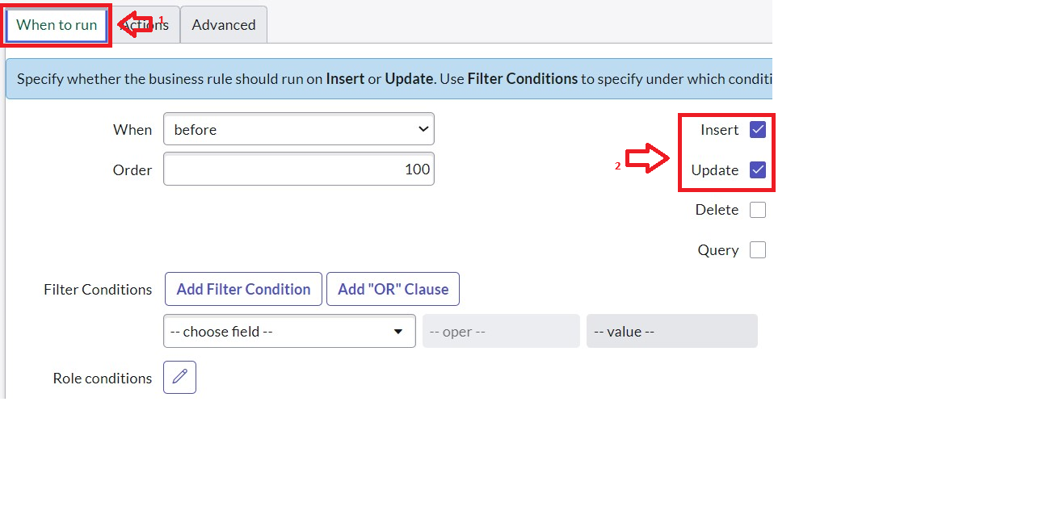

1. In Advance(we write the code): Write the below code >>

(function executeRule(current, previous /*null when async*/) {

var FamilyExpenses = new GlideRecord('u_family_expenses');

FamilyExpenses.addQuery('u_date',current.u_date);

FamilyExpenses.query();

if(FamilyExpenses.next())

{

FamilyExpenses.u_amount += current.u_expense;

FamilyExpenses.u_expense_details += ">"+current.u_comments+":"+"Rs."+current.u_expense+"/-";

FamilyExpenses.update();

}

else

{

var NewFamilyExpenses = new GlideRecord('u_family_expenses');

NewFamilyExpenses.u_date = current.u_date;

NewFamilyExpenses.u_amount = current.u_expense;

NewFamilyExpenses.u_expense_details += ">"+current.u_comments+":"+"Rs."+current.u_expense+"/-";

NewFamilyExpenses.insert();

}

})(current, previous);

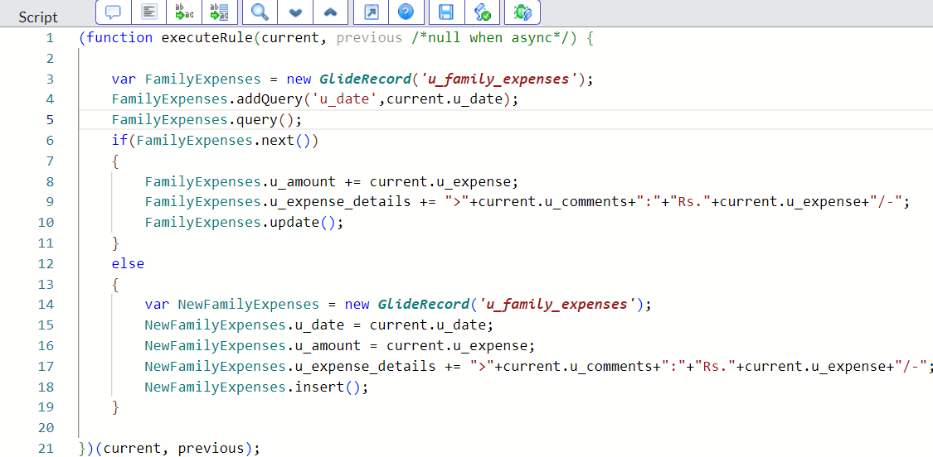

1. Go to the Header and right click there>> click on Save.

### Milestone 9: Configure the Relationship

### Activity 1: Configure the Relationship

1. Go to All >> In the filter search for Relationships >> Open Relationships.
2. In that, open Daily Expenses Relationship.
3. For Applies to table : Select Family Expenses.
4. In Query with : write the below Query.

(function refineQuery(current, parent) {

// Add your code here, such as current.addQuery(field, value);

current.addQuery('u_date',parent.u_date);

current.query();

})(current, parent);

1. Click on Update.

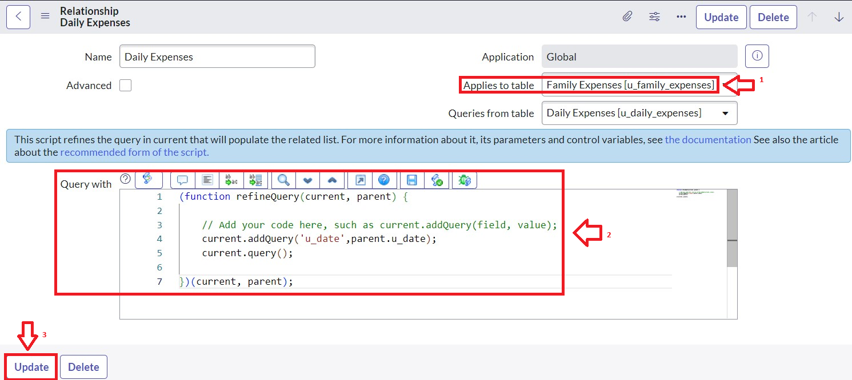

### Conclusion

**A ServiceNow project to calculate family expenses concluded with successfully leveraging the platform's capabilities to track and manage expenditures. The project automated data entry through custom forms, categorized expenses for better analysis, and provided real-time dashboards and proactive budget alerts. The ultimate conclusion is that this ServiceNow-based solution empowers families with intuitive, data-driven tools for effective budgeting and informed financial decision-making**